Activity sheet 7: Pizzas and more looping

Starter program

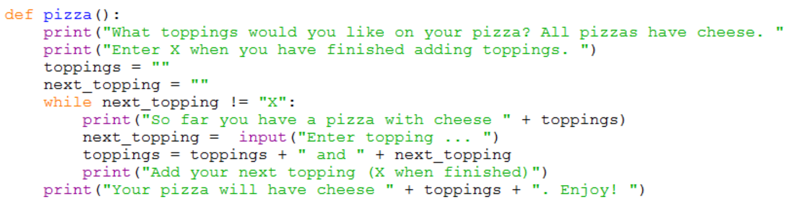

Task 2: Download and run the program and see if it does what you think it might do. You will find it at <insert your shared drive link here>

Did the program run as you predicted? ____________________________________

Task 3: In pairs, work out the answers to the following questions by examining the code and running it a few times.

- What happens if you don’t add any toppings?
…………………………………………………………………………………………………………
- If you run this program and the user wants to add pineapple, olives and mushrooms, fill in the following table.

next_topping | toppings
 | and pineapple
olives
mushrooms

- Why do you need a while loop?
…………………………………………………………………………………………………………
- What would happen if you didn’t have the line next_topping = ""? (try it and see)
…………………………………………………………………………………………………………
…………………………………………………………………………………………………………
- What would happen if you didn’t have the line toppings = "" (try it and see?)
…………………………………………………………………………………………………………
…………………………………………………………………………………………………………
- What does this line do?
…………………………………………………………………………………………………………
…………………………………………………………………………………………………………
- How would you like to improve this program?
…………………………………………………………………………………………………………
…………………………………………………………………………………………………………
Now add comments (beginning with #) to the program to make sure everything you understand is included in your program for future reference. When you think you understand how this program works then go on to the exercises.

Task 4: Exercises

In pairs, try these challenges:

- Improve the pizza program so that it doesn’t print out “and X” at the end. You will have to add an “if” statement to do this.

- Write a version of the game “I went shopping and .. “ . Then try it on somebody who can’t see the computer to see if they can remember everything the computer has stored from the shopping game? The game should stop when the user presses the enter key rather than adding another item.
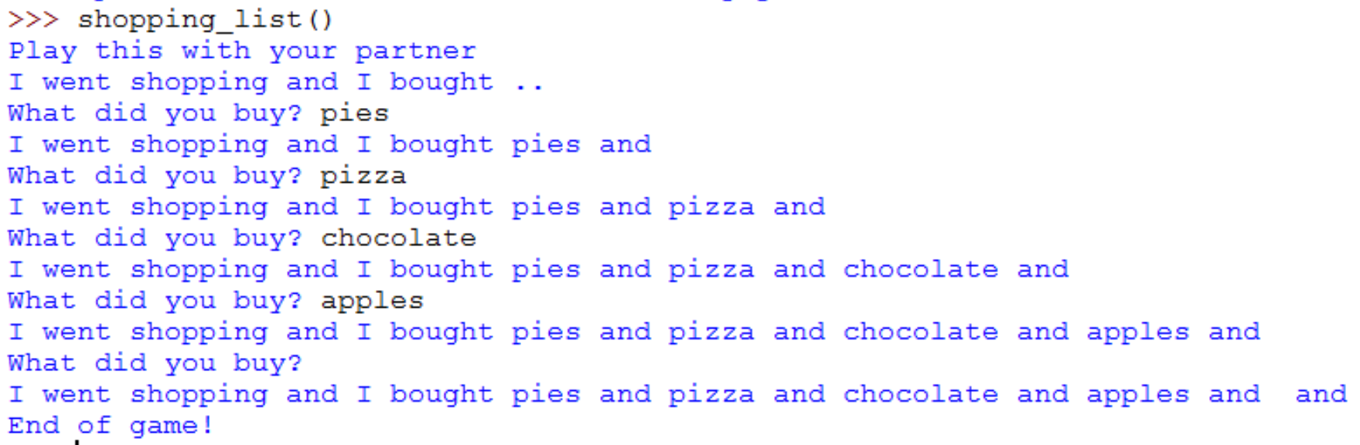

- Improve the version so that it doesn’t end with “and” . (This exercise is similar to exercise 1.

- Below is a program for a guess the number game that will only run once. The computer comes up with a random number and the user has to guess it.

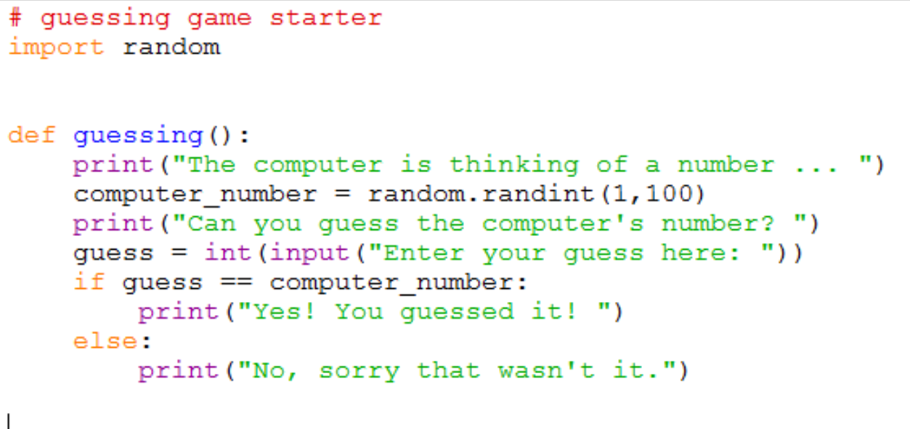
Modify this program using a while loop so that it keeps asking the user for another number until they guess it correctly. If they guess the number correctly it should display a well done message which includes their name.
- If they guess a number that is higher than the actual number output “Too high”.
- If they guess a number that is lower than the actual number output “Too low”.
- Ensure you add comments explaining your code.

Extension tasks

Try the following statements out in the Python shell (not in a new file).

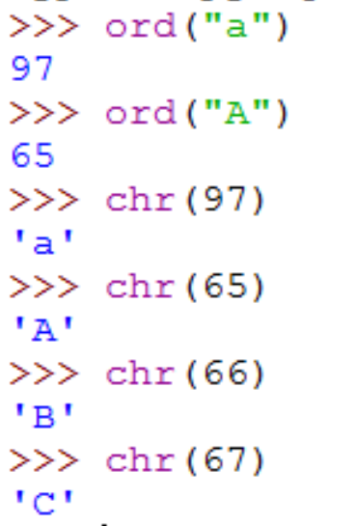

ord() and chr() are functions that you can use to work out the ASCII code in decimal for characters that are entered in the keyboard.

- Write a program that will write out all the letters from “a” to “z” using the chr function and either a for loop or a while loop.
- Write a program that will ask the user for a character and output its ASCII value.

