Activity sheet 9a: Using buttons and forms
In this week’s session we will focus on programming using an environment called EasyGui which allows the use of windows and buttons.

Task 1: Using EasyGui to make forms and dialog boxes in Python

EasyGui is a module that can be imported into a Python program to enable simple graphical user interfaces to be developed.

To start using EasyGui, copy the program easygui.py into the folder that you are using for your python programs. It is available at <insert your shared drive here>.

Then open the starter program and run it. For the first program the output is shown. See if you can predict what the other examples will do then run the programs to test them.

Program | Draw what you think will happen | Were you right?  (/)
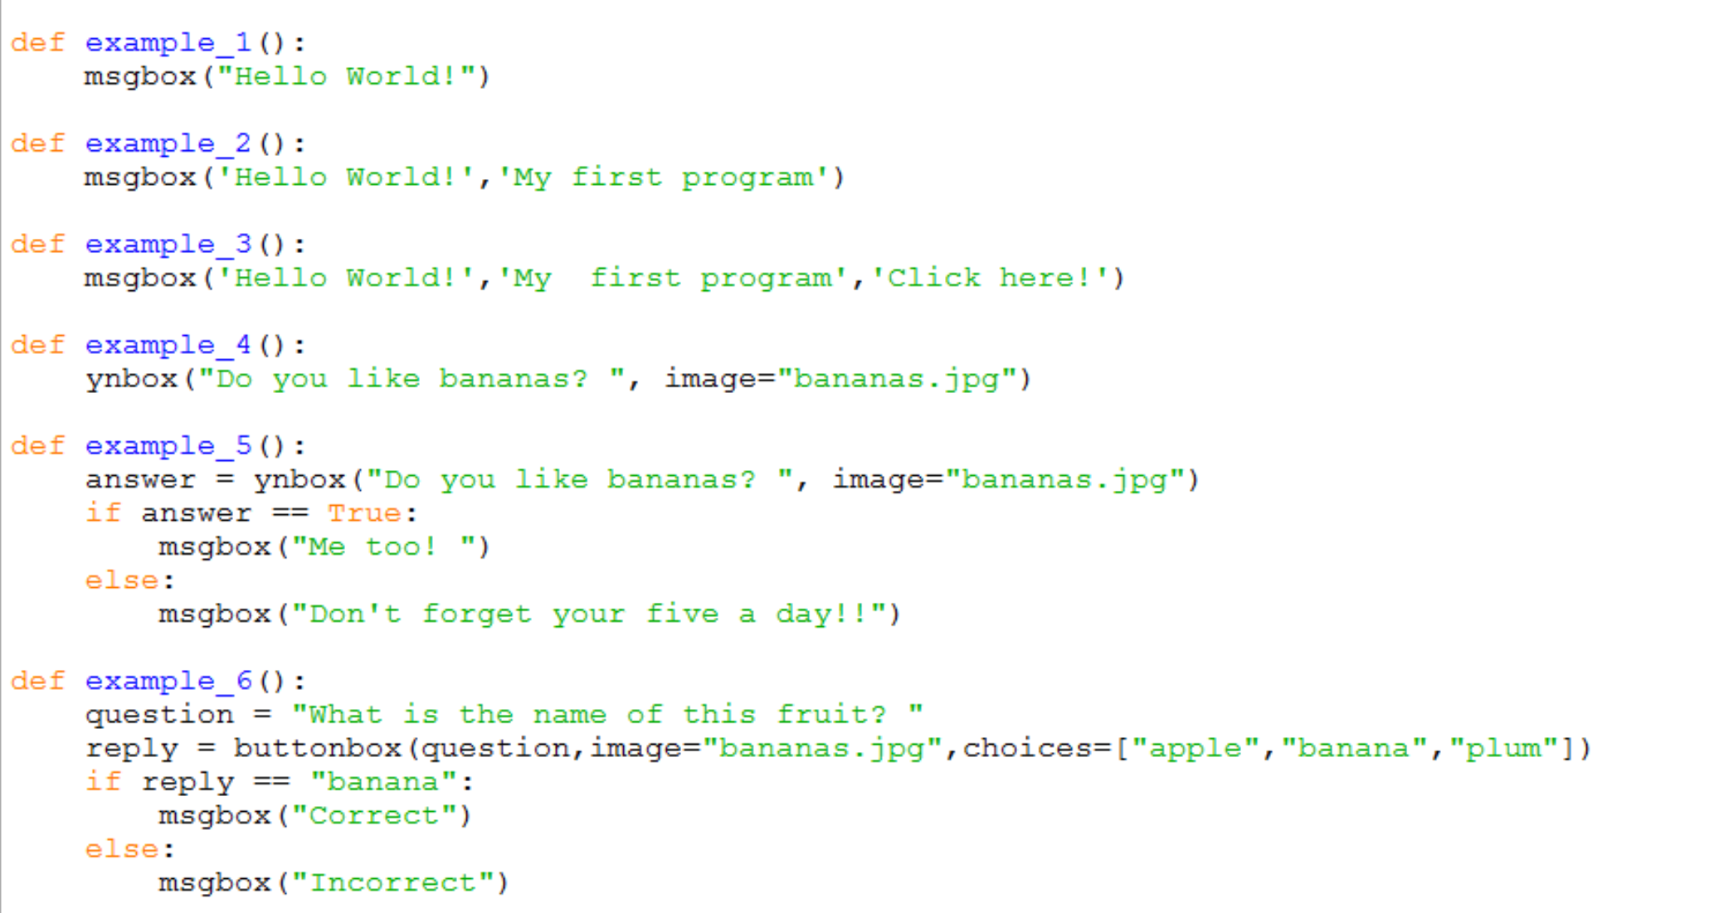 | 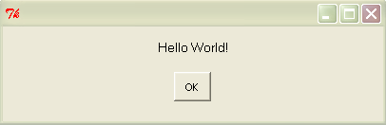
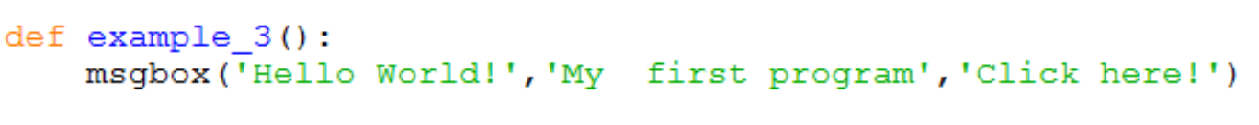
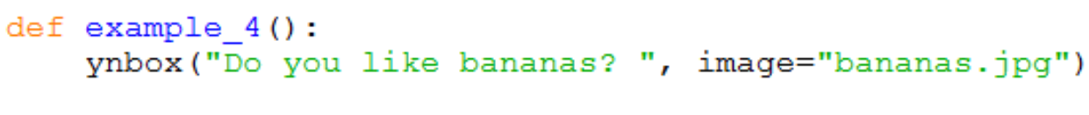
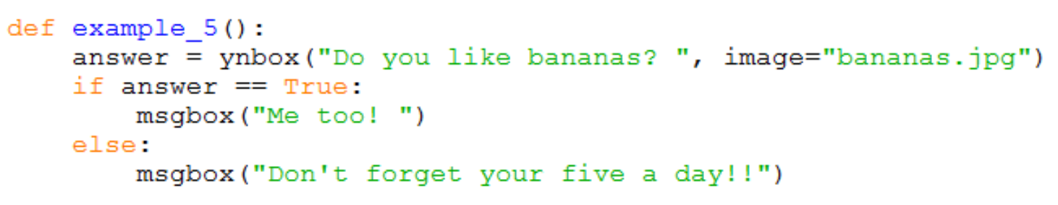
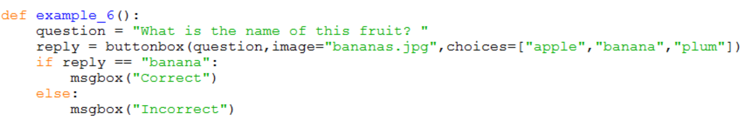

Task 2: Add comments (begin with #) to the code in Examples 1 – 6 to explain how you think it works.

Make sure you are confident that you have run and understand the code in the examples before continuing with the exercises.

On sheet 9b there are exercises to try using the different boxes available in EasyGui.

