Activity sheet 6c: Python Programming and while loops

Use the starter program to help you do these exercises by copying it and changing it for each exercise. As you write these programs, make a note of any errors that you come across in the notebook and how you fix them.

These programs use different operators. Remember the operators are as follows:

== is equal to
!= is not equal to
> is greater than
< is less than
>= is greater than or equal to
<= is less than or equal to

- Write a program that writes “Today is Monday” one hundred times using a while loop. Compare this to the way that we might have done this last week with a for loop. | 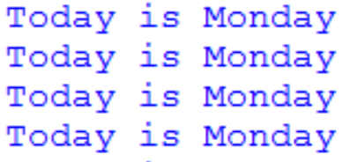  …… and so on ….
- Write a program that asks the user for the name of the recent storm and keeps asking until they put in the name “Doris”. To the right is some code for the input statement to get you started | OR
- Write a program that asks the user for a number until they put in 99. When they put in 99 the program stops. | 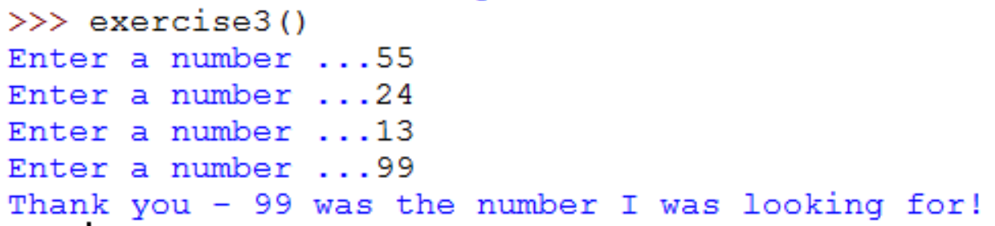
- Write a function bored() using a while loop that has the output shown to the right.  Start with  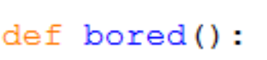 | 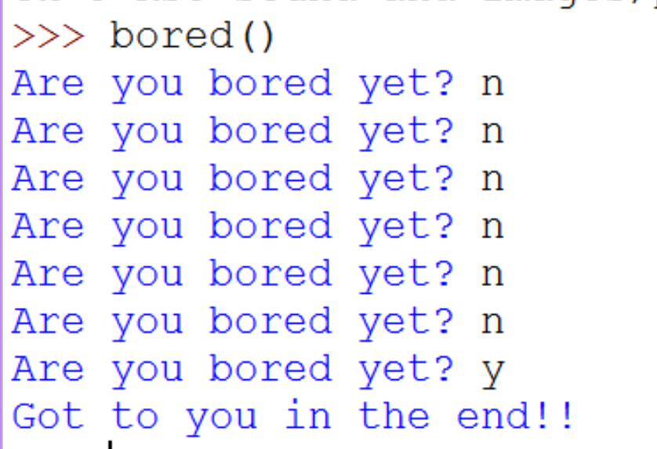
- Write a program that prints 1 to 10. You can do this with a while loop or a for loop. Try to do it both ways. | 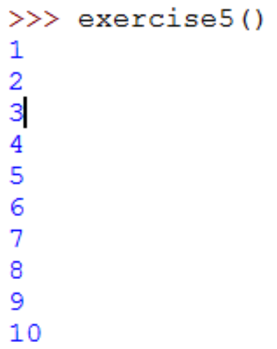
- Now change your program from (5) so that it prints the numbers from 10-1. | 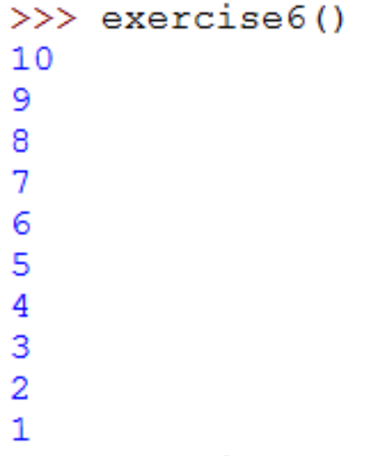
- The program to the right asks the user for a password. When does the program stop? Run it and see.  Next add some code to count how many tries the user has had and print that out at the end of the program.  How else might you improve this program? | 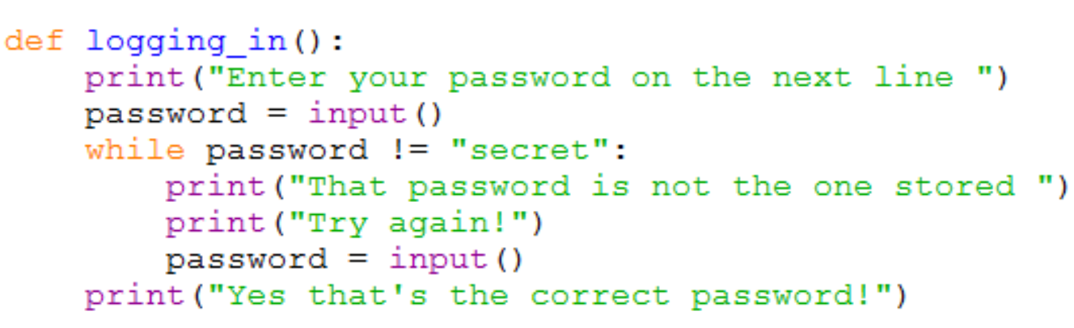
- Improve the quiz you wrote in week 3 by adding a while loop. Keep asking the question until the user gets it right. | 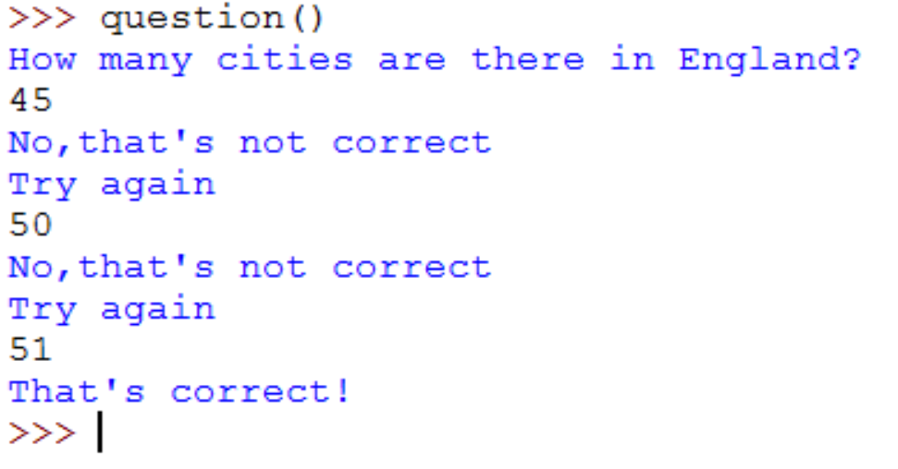

Key concepts to remember

Term | What it means | How to do it in Python
Iteration | A loop. There are two loops – for loops (a set number of repetitions) and conditional loops or while loops. | 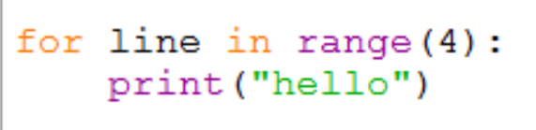  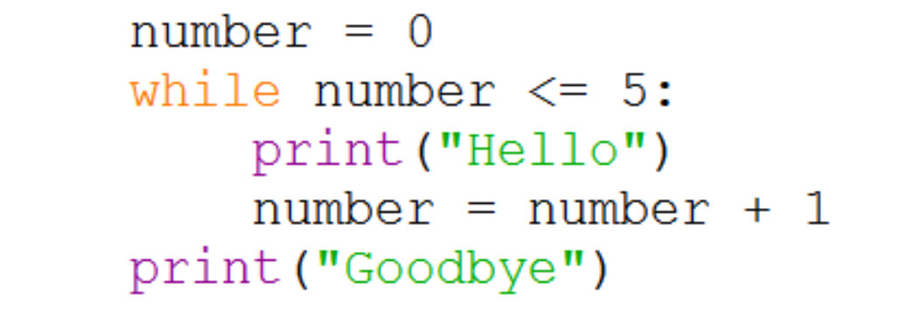
Variable | Something you can give a value to and then change it at other times in the program. | 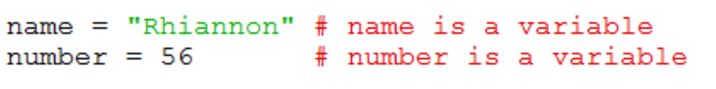
Selection | Where there is a choice point in the program design and an if statement is used to create more than one possible pathway. | 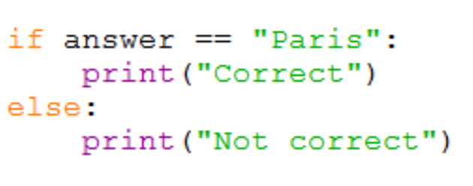
Input/Output | Getting input from the keyboard or outputting something to the screen. | 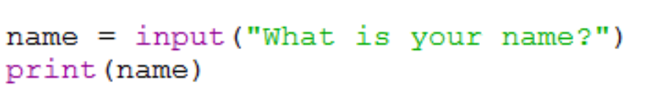
Assignment | Where a variable is given a value | 