Activity sheet 6a: Python Programming and while loops
This lesson is about a different type of loop – the while loop

Task 1: Predict In pairs, look at the program below and write out what you think might happen when it runs.

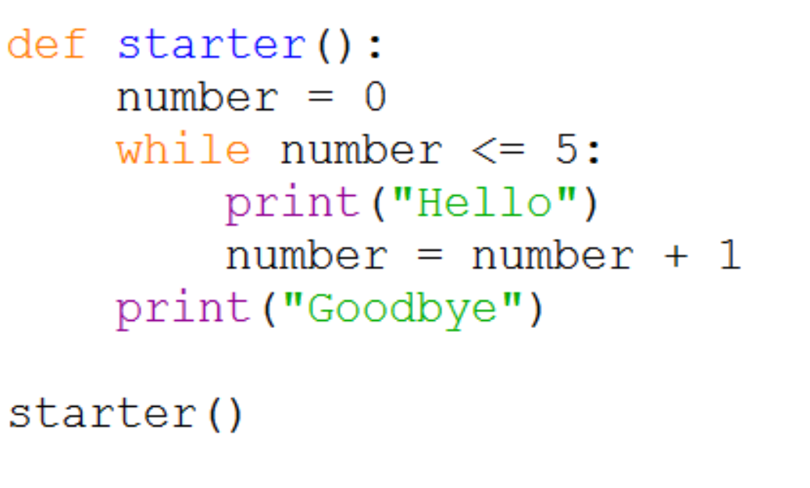
What would you expect the computer to do? Write the output exactly as you think it will appear.

Task 2: Run Download and run the program and see if it does what you think it might do. You will find it at <insert your shared drive here>

Did the program run as you predicted? ____________________________________

What were the differences? _____________________________________________

