Activity Sheet 4: Making choices
Last week you used functions to make programs shorter and to allow you use re-use code. This week we will leave turtles for a week and look at user input and selection (using if). The demonstration will cover the use of the Python shell and assigning values to variables.

Task 1: In pairs, look at the program below and write out what you think might happen when it runs
What would you expect the computer to do? Write it out exactly.

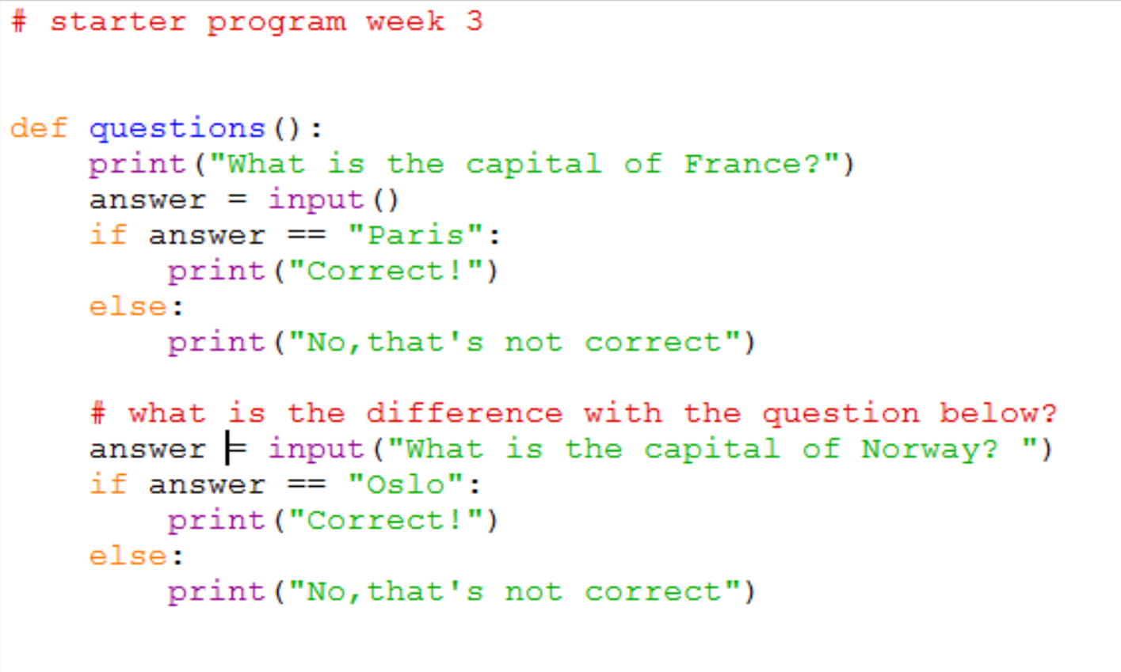

Task 2: Download and run the program and see if it does what you think it might do. You will find it at <insert your shared drive here>

Did the program run as you predicted? ____________________________________

Task 3: There are a few new concepts in this program. In pairs, work out the answers to the following questions by examining the code and running it a few times. (These are good questions to ask your students!!)

- Name a variable being defined in this program _________________________
- What would happen if you typed Print() instead of print() ________________
__________________________________________________________________
- What would happen if you wrote that London was the capital of France?
__________________________________________________________________
- Why do you need a colon : at the end of the if statement and the word else
_________________________________________________________________
- What is the difference between = and == ? Both are used in this program.
_________________________________________________________________
- What happens when you run answer = input()
_________________________________________________________________
- What is the difference between
answer = input() and answer = input(“What is the capital of…”) ?
________________________________________________________________

________________________________________________________________

Now add comments (beginning with #) to the program to make sure everything you understand is included in your program for future reference. When you think you understand how this program works then go on to the exercises.

Once you write programs that have if statements you must test both options!!

Task 4: Exercises

In pairs, try these challenges:

- Add two more questions and answers about capitals. If you get any syntax errors along the way be sure to write them down for later reference!
- Now extend your program to give a more personalised answer with name. In a print() or input() statement you can use a “+” to join up a variable and some text inside “ “.

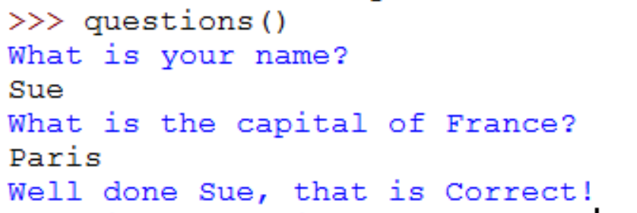

- Now ask a question with a numeric answer , for example “How many cities are there in England?” Use int(input(…)) to do this. The extra int() wrapped around the input will convert what you typed in into a whole number.

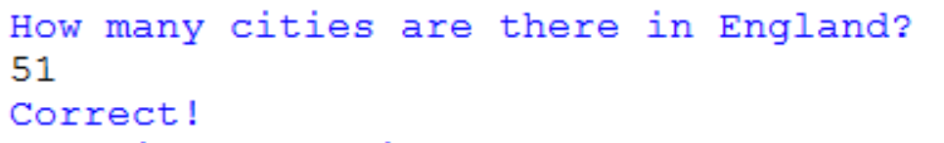

Note that if you don’t use int(input()) and try to enter a number you will get an error. You could try to generate this error to make a note of it.

- Now extend your program to include a multiple-choice question. "a. …"

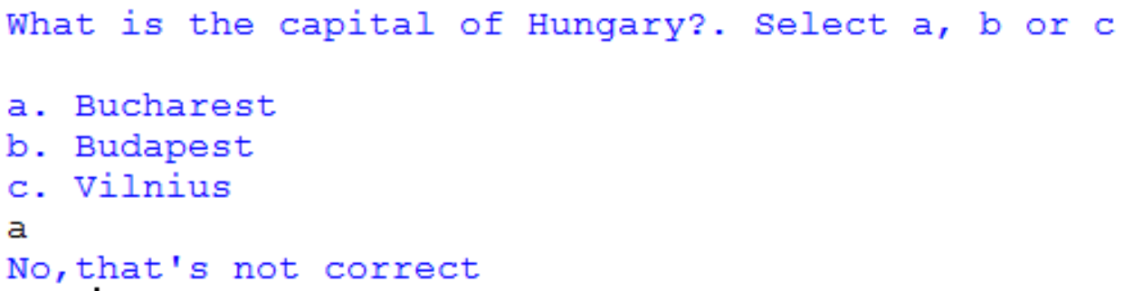

Extension exercise

Go back to the turtle program you wrote last week and add some user input. Ask the user if they want a large square or a small square, and draw the square appropriately. For an additional challenge, you could also do this with the colour of the square.

Make a note of any errors that you come across in the notebook and how you fix them.

Key concepts from this sheet:

Term | What it means | How to do it in Python
Variable | Something you can give a value to and then change it at other times in the program | 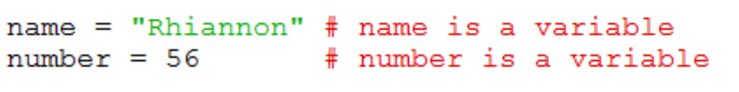
Selection | Where there is a choice point in the program design and an if statement is used to create more than one possible pathway. | 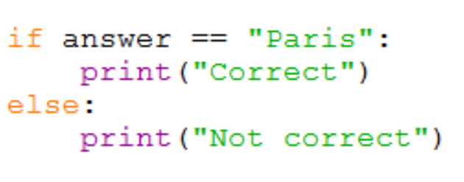
Input/Output | Getting input from the keyboard or outputting something to the screen. | 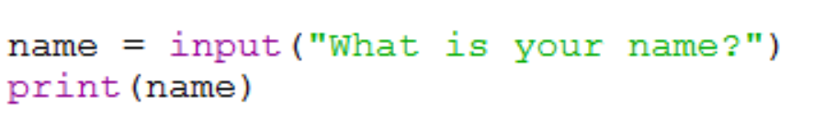
Assignment | Where a variable is given a value | 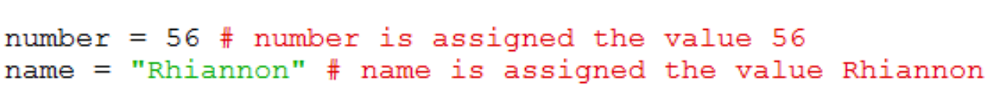
Condition | What we test for inside an if statement. | 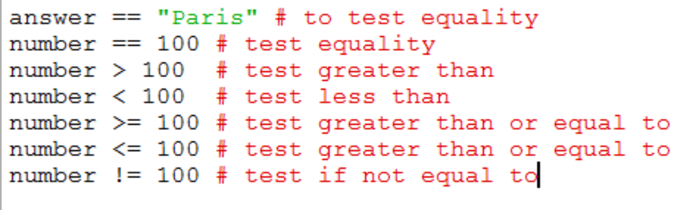
Testing | Testing is essential to make sure that each pathway works correctly | Run the program as many times as there are options or combinations of options to ensure each pathway works. You can plan this using a test plan which is a table to record the results. A test plan makes sure your testing is systematic.

Key points to remember in Python

- The colon : is used to announce that a new block of code is coming and all the lines in the block MUST be indented the same amount of spaces. At the end of the block, you can stop indenting. Anything that happens if a condition is true after an if statement is also a block of code.
- Python is case sensitive so Triangle and triangle will be treated as completely different things.
- ‘Name error’ is an error you get if the variable name or function name you have used in Python is not recognised. Sometimes it’s caused by a lower case/upper case mis-typing or a spelling error.

