Activity Sheet 11: 1D Arrays/Lists in Python
This sheet focuses on how to work with 1 & 2D lists in Python. Arrays and lists are both data structures which allows a group of values to be assigned to one identifier. This avoids the use of multiple variables to store a group of values.

Arrays are fixed in size and can only store groups of values of the same data type. Lists on the other hand can grow and shrink in size and store groups of values of mixed data types. Python doesn’t use arrays, only lists, therefore this activity will focus on the use of lists in Python.

Task 1: In pairs, look at the program below and write out what you think might happen when it runs
What would you expect the computer to do? Write it out exactly.

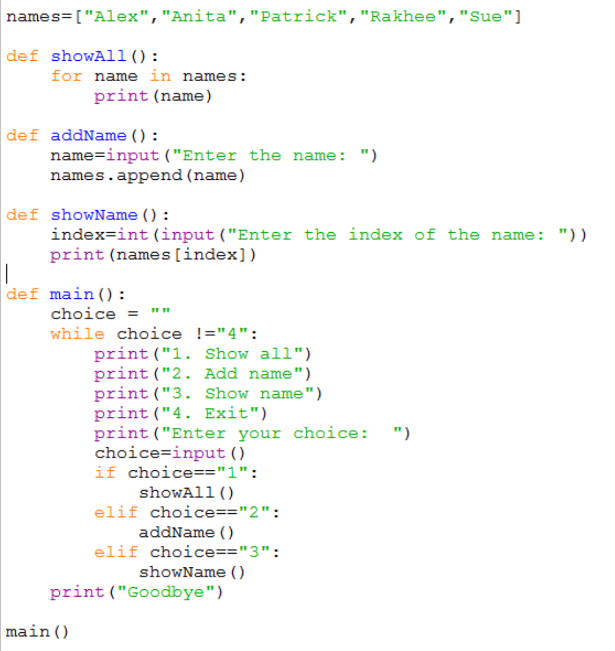

Task 2: Download and run the program and see if it does what you think it might do. You will find it at <insert your shared drive here>

Did the program run as you predicted? ____________________________________

Task 3: In pairs, work out the answers to the following questions by examining the code and running it a few times.

- What would happen if you choose option “3” and entered index “0”? __________________________________________________________________

- What would happen if you choose option “3” and entered index “7”?
__________________________________________________________________
- Give an example of a list used in this program.
_________________________________________________________________
_________________________________________________________________
- What would happen if you choose option “2” and entered the name “Stuart”?
_________________________________________________________________
_________________________________________________________________
Now add comments (beginning with #) to the program to make sure everything you understand is included in your program for future reference. When you think you understand how this program works then go on to the exercises.

Task 4: Exercises

In pairs, try these challenges:

- Extend the program to enable the first name to be displayed. You will need to add a new function and update the if statement to allow the user to choose the new option.

- Now extend the program to enable the last name to be displayed. You will need to add a new function and update the if statement to allow the user to choose the new option. You can find the length of a list using the “len” method, for example:
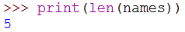
As the index of the first name is 0, you will need to subtract 1 from the length to get the index of the last name.

Challenge
Write a new program for an average mark calculator. It will need to ask the user how many marks they wish to input and use a for loop to get each mark and add it to a list. The program should then use another for loop to add the marks together and calculate the total mark. Next is can work out the average by dividing the total by the length of the list.

Finally, the average mark should be outputted to the user.
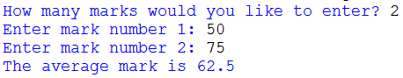

HINT: You will need to create an empty list at the start of your program to store the marks in.

