Activity Sheet 10: Python Programming – Maze game
In this week’s session we will focus on working with one larger program that can be extended in a number of ways.

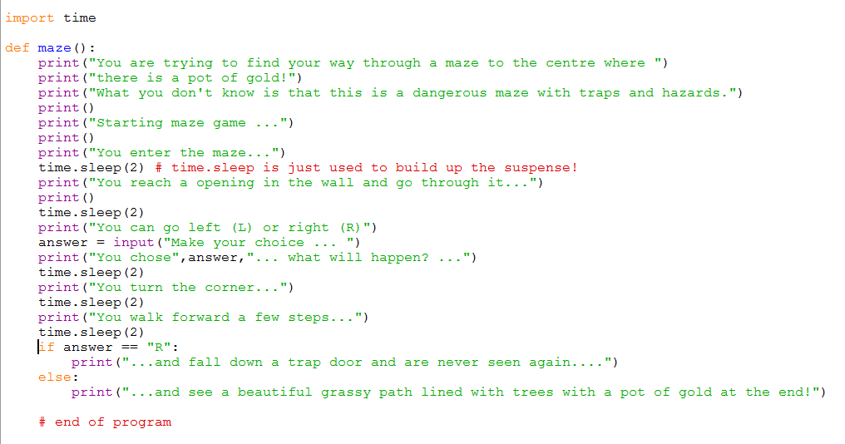
Task 1: Predict

What will this program do? ___________________________________________

____________________________________________________________________

____________________________________________________________________

Task 2: Run
Download the starter program from <insert your shared drive here>
Run it and see if it does what you expected.

Task 3: In pairs, modify this program however you want. Design your changes in advance.

You may wish to draw a flowchart to demonstrate what your program will do. Here is an example.

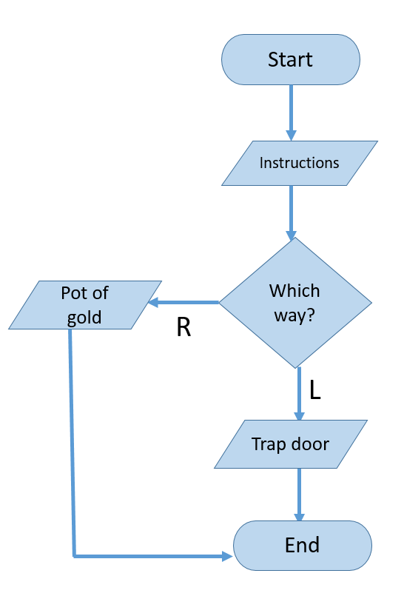
Example of a flowchart for the maze starter program

Some suggested changes that you could build into the maze:

- Ask the user if they want to go left, right or straight ahead.
- Change the “pot of gold” option to another room and then have another option to exit by a blue door or a red door.
- Use a loop to make sure that they can’t continue until they put in one of the options.
- Give the user a point every time they progress through one door and build in a few levels of doors and questions.
- Change the scenario completely.

To help you with this task:
- Write down in advance, or draw in a flowchart, what you want your program to do.
- Identify if you will need any new variables to store data
- Keep earlier versions of your program in case you get in a muddle!

